
Visit to Sledmere House and Gardens 25th July 2013



These photographs show the house and adjacent orangery. The garden has recently been redesigned.
The library is a splendid room and the ceiling is magnificent.
Both photographs were taken from the Sledmere House website, where more information can be found.
www.sledmerehouse.com
Our guide round the house was most informative and had many interesting and amusing snippets of information. We wished that we could have stayed twice as long!
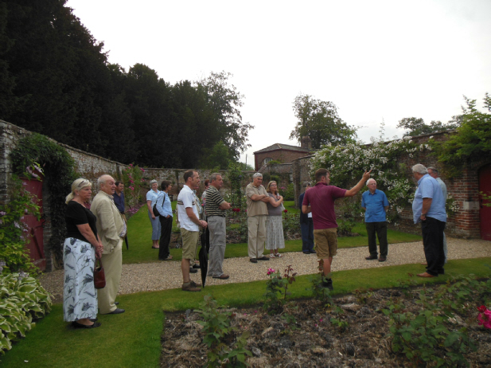
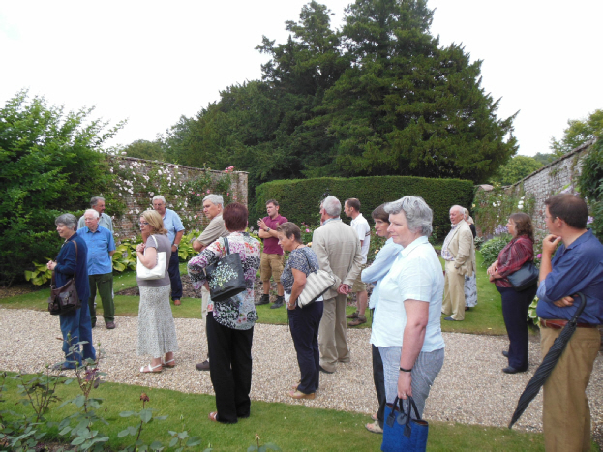
We then enjoyed a tour of the gardens with the head gardener. He explained how the gardens were gradually being changed to enable easier and more sustainable management, owing to the lower number of staff.

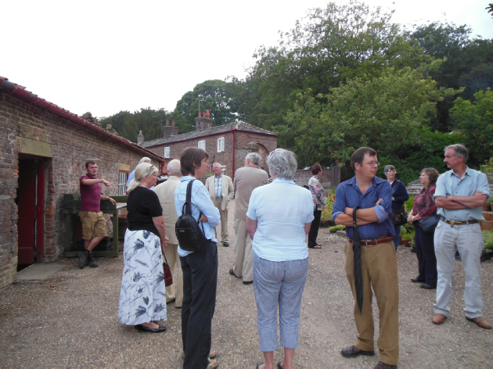

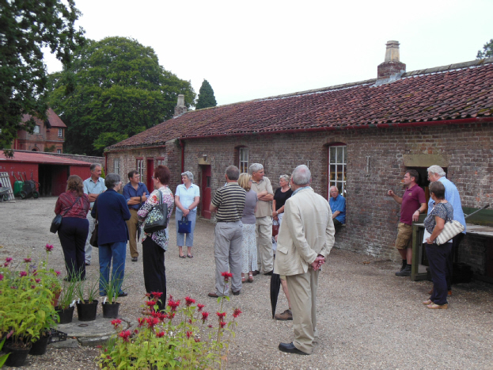

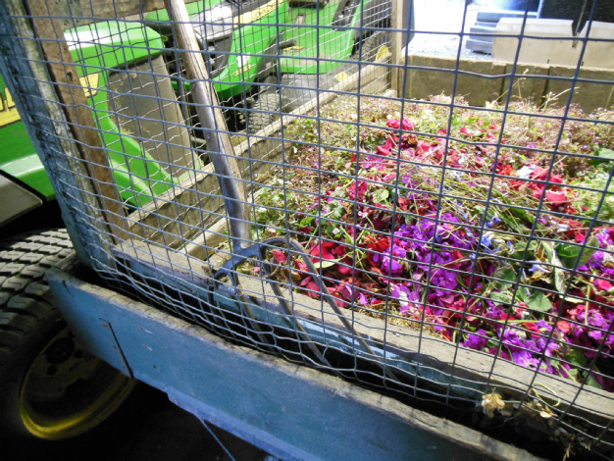

Colourful compost

